SR 400/McGinnis Ferry Road Interchange
Status Update – May 2016
GDOT PI # 0007526

Project Description
The project proposes to add a full access diamond interchange at McGinnis Ferry Road which currently overpasses SR 400 with no access to the freeway. Because McGinnis Ferry Road follows the County line at this point, the south half of the project is in Fulton County, and the north half is in Forsyth County. The two-lane McGinnis Ferry Road bridge over SR 400 would be demolished and replaced with a wider structure allowing for turn lanes to ramps for SR 400 and a multi-use path for pedestrians and cyclists. The proposed bridge would be designed to span the future managed lanes on SR 400. In addition, McGinnis Ferry Road will be widened to four lanes to the west of SR 400 and six lanes to the east of SR 400 with a typical that would include curb and gutter with 5 foot sidewalks and/or a multi-use path. This widening is necessary to accommodate the traffic volumes that are expected to increase with the interchange access and planned development along the corridor. In addition, the project would include auxiliary lanes in both directions along SR 400 between Windward Parkway and McFarland Parkway interchanges.
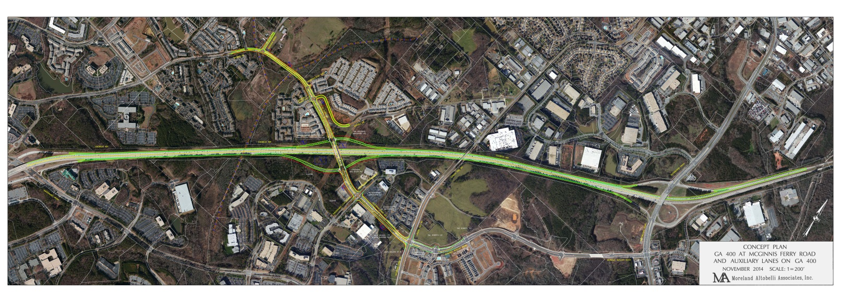
Current Status
A Project Framework Agreement (PFA) between the Georgia Department of Transportation (GDOT) and Forsyth County was executed on January 9, 2015. The Interchange Justification Report and the project concept report have been approved by GDOT. In order to advance the project, the North Fulton CID and a local developer have agreed to fund the local match for preliminary engineering. The database preparation is complete and is being reviewed by GDOT for approval. Most of the environmental special studies are complete and are already approved by GDOT. The alignment is set and work is on-going related to the plans and profiles as well as looking at the major drainage crossings. The following are the completed milestones to date:
- Interchange Feasibility Report (IFR) GDOT approval – March 2010
- Interchange Justification Report (IJR) GDOT approval – February 2013
- Concept Report GDOT approval – November 2014
- Public Information Open House – September 2015
Below are the projected milestone dates for the key outstanding activities:
- Environmental approval – December 2016
- Right of Way acquisition completion – February 2018
- Construction let date – May 2018
Project Funding Summary
Phase | State/ Fed Commitment | City of Milton Commitment | City of Alpharetta Commitment | Forsyth County Commitment | NFCID Commitment  thru 2015 | Private Investments | Total Estimated  Costs*
Interchange Feasibility Report (IFR) |  |  |  | $50,000 | $100,000 | $25,000 | $175,000
Interchange Justification Report (IJR) | $100,000 | $0 | $0 | $25,000 |  |  | $125,000
Concept Report | $146,000 |  |  | $36,500 |  |  | $182,500
Engineering | $1,560,000 | $0.00 | $0 | $190,000 | $200,000 |  | $1,950,000
Right-of-Way | $5,000,000 | $0 | $0 | $8,304,000 | $0 | $0 | $13,304,000
Utilities | $3,852,000 | $0 | $0 | $0 | $0 | $0 | $3,852,000
Construction | $28,566,524 | $0 | $0 | $0 | $0 | $0 | $28,566,524
TOTAL | $39,224,524 | $0 | $0 | $8,605,500 | $300,000 | $25,000 | $48,155,024

*Inflation included in estimated costs

